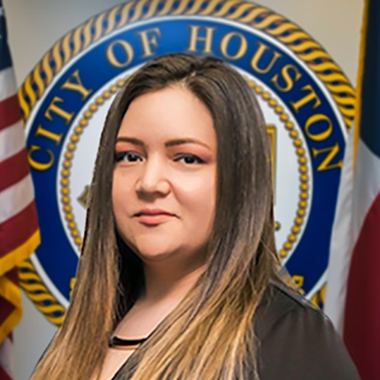
Lisa Stricklan, Getting Back to Safety
Lisa Stricklan started her career with the City of Houston (COH) as a Safety Officer in the Human Resource’s Risk Management Division. Motivated by learning and having the ability to teach others Lisa moved to the Learning Center as a Training Coordinator in HR’s training department. After six months in this role, Lisa learned how to communicate training through adult learning techniques and how to navigate the Talent Management System. Lisa’s passion and dedication to safety brought her back to the Safety Officer role!
Lisa’s passion for safety doesn’t start or stop when she is only at work. She prides herself on actively teaching her three kids of hazards all around whether she is at home or in public. For example, muster points in the event of a fire at home, heighten awareness of where all exits are when they are in the public in case of a fire or active shooter events, and good housekeeping to prevent trips, slips, and falls. Her husband, a Navy veteran, also helps with identifying hazards and teaches them how to keep their “head on a swivel.” This is a military quote meaning to stay alert and aware of your surroundings.
Lisa has a Bachelor of Science in Business degree, and since she started with the COH four years ago, she has continued learning by earning her Certified Occupational Safety Specialist (COSS) certification. She is working on earning a Certified Safety & Health Official (CSHO) though the University of Texas at Arlington’s OSHA Education Center. Lisa is a certified instructor for Work-Zone Traffic Control (2-Day) training course, and a First Aid, CPR & AED instructor though National Safety Council (NSC) for the COH.
“I came back to Safety because I felt I could help the Houston Public Works (HPW) department continue to work safely and follow the goal of Zero Is Possible, as well as utilize my training skills and be a direct asset for HPW’s department.”
In Lisa’s free time she likes to spend time with her family making safe and fun memories. She has a crafty hobby specializing in machine embroidery for hats and various items.
“To the COH employees, remember you only have ONE you. No matter what the circumstances are in your work or daily life your safety comes first. Don’t chance it! Ask questions if something seems off and share ideas and advise you have to do things in a safer manner. As always, if you see something say something. You could be the key to saving someone else’s life or yours!”

