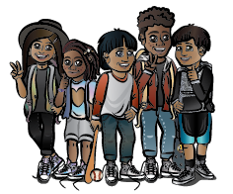
Bounce Back for Classrooms
Pilot Site Information Sheet

What is Bounce Back for Classrooms?
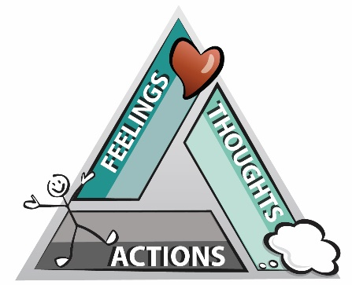
Bounce Back for Classrooms, an adaptation of the trauma-focused group counseling intervention Bounce Back (Langley & Jaycox, 2015), is a social and emotional learning (SEL) curriculum based on cognitive behavioral therapy components. Bounce Back for Classrooms was developed by the National Native Children’s Trauma Center (NNCTC) housed at the University of Montana. Use of the curriculum in a classroom setting supports students in understanding and mitigating the effects of stress and traumatic stress, fostering hope, and building skills that promote healing and resilience. The curriculum is one element of a multi-tiered trauma-informed school system as a Tier 1 or universal strategy suitable for all students. The curriculum is developmentally appropriate for students between 2nd and 5th grade. Each of the 12 lesson plans fits within an approximate 50-minute time frame and can be facilitated by classroom teachers, school counselors, or other youth service workers—no clinical training is required.
Lesson topics include: the body’s danger response, signs of stress and trauma, connections between thoughts/feelings/behaviors, identifying feelings in self and others, measuring intensity levels of feelings, regulating feelings, identifying helpful and unhelpful thoughts, generating helpful thoughts, social problem-solving, and identifying resources of support.
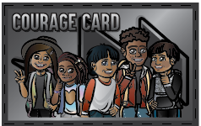
What are the recommended criteria for implementing Bounce Back for Classrooms?
Bounce Back for Classrooms aligns well within school-based multi-tiered student support approaches such as Multi-Tiered Systems of Support (MTSS) and Positive Behavioral Interventions for Support (PBIS). Because Bounce Back for Classrooms is trauma informed it fits best within a trauma-informed system. According to the Substance Abuse and Mental Health Services Administration (SAMHSA), a trauma-informed system is one that realizes the widespread impact of trauma, recognizes the signs and symptoms of trauma, responds by integrating trauma knowledge into practices, procedures, and policies, and works to resist re-traumatization among students, staff, and families. Recommendation for school readiness to implement Bounce Back for Classrooms include:
- Administration and school climate that support SEL implementation
- General knowledge among staff members about the impacts of trauma on learning and behavior
- General knowledge of best practice strategies staff can use to support all students, particularly those students exposed to trauma
- Use of trauma-informed principles, such as positive behavioral supports and positive discipline
- A general agreement and understanding among staff to utilize the adult/student relationships to build trust, understanding, and safety
- A six-hour training on implementing Bounce Back for Classrooms that can be delivered virtually or in-person

What can be expected as a pilot site?
Bounce Back for Classrooms is in the pilot stage of development. The curriculum has been written and reviewed by colleagues from mental health and education backgrounds. Before the curriculum is ready to be widely distributed, our Center would like to follow the implementation of the SEL from start to finish while obtaining feedback regarding relevancy, effectiveness, and ease of flow. We would also like to offer technical assistance in implementing Bounce Back for Classrooms as requested by the site. We are requesting sites interested in implementing Bounce Back for Classrooms participate in the following requirements:
- Participate in the six-hour Bounce Back for Classrooms implementation training.
- Complete a short feedback form per each lesson; a 5-10-minute time commitment per form.
- Participate in two calls with the developers regarding technical assistance in implementation; a 30-45-minute time commitment per call.
- Facilitate a knowledge survey created by the developers to be given to students pre and post; a 2-hour time commitment. Share anonymous results with the developers.
- Participate in technical assistance calls with the NNCTC developers as needed.

For More Information, Contact:

Debra Klemann
debra.klemann@mso.umt.edu

Amy Foster Wolferman
amy.FosterWolferman@mso.umt.edu

