Instructions: Create a new user account on the Eligible Training Provider List

To set up a new user account, go to the ETPL. You will see an option to create a new account:

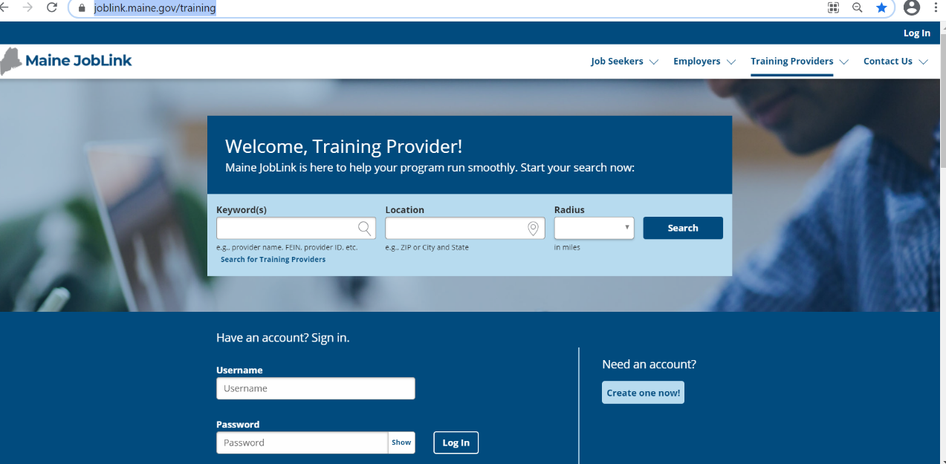

On the next screen, you will then enter the training provider’s FEIN (Federal employer identification number).

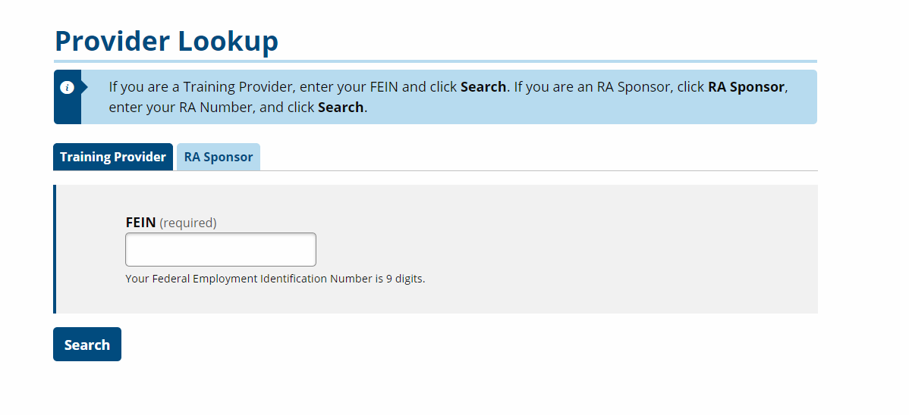
Once you enter the FEIN, you will see a screen asking you for information.

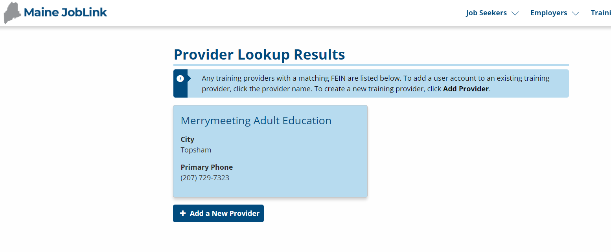

Training Provider Name

If you are establishing a new user account for a training provider who is already on the ETPL, click the provider name.

If you are adding a brand-new training provider to the ETPL, click Add a New Provider.

Just follow the prompts, fill in all the info. The Maine JobLink will send you an email asking you to confirm your email address. Please confirm your email address; this will allow you to reset your password when needed.

If your training institution already has an account, your user account will be connected to its current listing on the ETPL.

Once you are approved as a new user, you can access your account to update your contact information and add, delete, and update programs.

For assistance, contact ETPLInfo.DOL@maine.gov

April 2021

