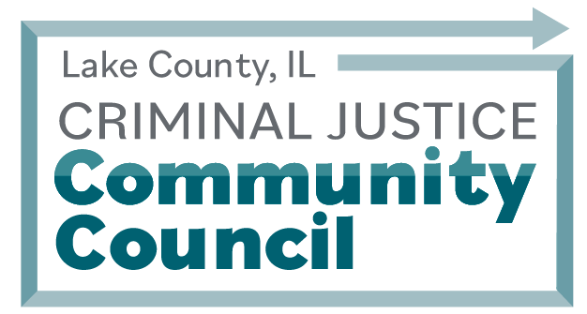
Meeting Minutes
Wednesday, September 14th, 2022 | 6 PM to 8 PM
Held Virtually Via Zoom and In-Person Meeting at the Sheriff’s Training Room
25 S. Martin Luther King Jr Ave. Waukegan, IL 60085
Attendees:
Sheriff John D. Idleburg | Lake County Sheriff’s Office (LCSO)
Donna Jo Maki | LCSO
Monique Johnson | LCSO
Kania Robinson | LCSO
David Olson | Loyola University
Eric Rinehart | Lake County State’s Attorney
Joy Gossman | Lake County Public Defender
Kevin Kuehmeier | Justice System Partners
Linda Bartmes | League of Women Voters
Jordan Kane | Color of Equity
Celeste Flores | Mano a Mano - Faith in Place
Todd Schroeder | 19th Judicial Circuit Court
Margaret Fontana | 19th Judicial Circuit Court
Dr. Fritz Gelin | Independence Center-Living Room Wellness Center
Lisa Johnson | Lisa Johnson Independence Center
Anthony McIntyre | Antmound Foundation
James Yanecek | LCSO
Bruce Johnson | Nicasa
Dr. Mary Roberson | NIRCO
Jackie Cunningham | Safe Illinois
Evonda Fulton | Antmound/Evonda Lynn Consulting
Sandra Bankston | Lake County State’s Attorney’s Office
Dave Franco
Steve Spagnolo | Lake County State’s Attorney’s Office

TOPIC | Discussion | Action Items
Welcome (Sheriff John D. Idleburg) |  | N/A
Lake County Criminal Justice Community Council Update | Overview of critical updates on the CJCC and its efforts | N/A
MacArthur Foundation Safety and Justice Challenge (SJC) Updates | Overview of the MacArthur Foundation Safety and Justice  Finding Solutions  Nationwide: 57 Counties, Cities, and States  Pillars of the SJC Initiative  Lake County 2021-2022 Strategies: Equity Team, Wellness Center, COAST, PSA, CJCC, Data Dashboards, and the  Lake County Jail Population, Bookings, and Disparities  Q&A from Council Members followed: Engage police departments | N/A
CJCC Election Discussion | Discussion on CJCC Bylaws including nomination of Chair, Co-Chair, and Secretary at the September meeting. Chair Sheriff John D. Idleburg will reach out to the community and council members to appoint a co-chair and secretary. | Member Johnson nominated Sheriff John D. Idleburg for Chair of CJCC in 2022-2022,  Seconded by _________,  All present approved the motion, no objections.  Sheriff John D. Idleburg affirmed at Chair.
2023 Strategic Plan Open Discussion | Q&A from Council Members followed: ARPA funds, housing/MH, how to house populations, safe/affordable housing, 2023 LC cash bond comparative | N/A
Presentation: LCSAO Gun Violence Prevention Initiative (SA Eric Rinehart) | Q&A from Council Members followed:  RFP closed July 9th; Color of Equity white paper; future presentation at Chiefs of Police meeting; racial profiling -IDOT data. | N/A
Closing Remarks and reminder of next CJCC Meeting: Wednesday, December 14, 2022 at 6:00 PM | The next CJCC meeting will be In-Person at the Sheriff’s Training Room | Adjourned: Approx. 7:30 PM

