- Nominate a Parent, Primary Caregiver or Guardian for The Children’s Trust of Washington Unsung Hero Award  Help us celebrate February as Parent Recognition Month as we honor 28 individuals around the state!  Since 2011, with your help, we have honored 253 individuals in Washington for the roles they have taken with their families, school and communities. They have been recognized because they have shown strength, courage and empathy in their communities.  Parenting is a wonderful learning and discovery process. Please take a moment to nominate a parent, primary caregiver or guardian who is working toward building one or more of these five protective factors.  Sponsored by: |  | Research has found Protective Factors reduce stress and promote the well-being of  ALL families.  Parental Resilience:  I can overcome hard times.  Concrete Supports in  Times of Need:  I know where to turn for help.  Social and Emotional Competence of Children:  I know how to help my children talk about their feelings.  Social Connections:  I have people who know  and support me.  Knowledge of Parenting and Child Development:  I know where to go to find out about parenting skills and my child’s developmental growth.
Unsung Hero Award Nomination Form
February is Parent Recognition Month in Washington. What better way to recognize a parent, grandparent, foster or adoptive parent or other caregiver than by acknowledging all the wonderful things they do to strengthen their family and those around them in the community.

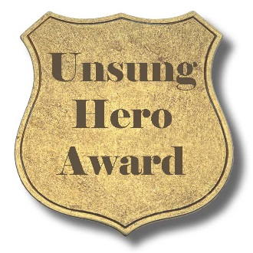
Do you know a parent, primary caregiver, guardian, foster or adoptive parent or a grandparent who shows one or more of these strengths: ability to bounce back from stress (parental resilience), a strong support system (social connections), understands their child’s developmental needs (knowledge of parenting and child development), shows empathy and support towards their child’s feelings (social and emotional competence of children), and not afraid to ask for help or receive help (concrete supports in times of need). Research has found that these five Protective Factors reduce stress and promote the well-being of ALL families. Everyone has stress, but when families increase Protective Factors, they build and draw on natural support networks within their families and communities.

Give us your nomination and we will give special recognition to 28 individuals from around the state by awarding them publicly with an Unsung Hero Award!

We invite you to nominate a parent, primary caregiver, or guardian who lives in Washington to receive this special Unsung Hero Award. Tell us what you think is so remarkable about them. We will select 28 nominees – one for each of the 28 days in February – for a special award. We acknowledge that this coming year will be virtual for celebrations during the month of February which is different than previous years so please note this change.

Please submit your nomination by January 11, 2021.
Email nominations to: strengtheningfamilies@dcyf.wa.gov.

Name of Nominee:
Mailing Address:
Phone:
Email:
Nominator:
Reasons you are nominating this person (please limit your response to 250 words or less):

