CWS/CMS Project

CWS/CMS Application

File Import Guide

July 20, 2019
Version 6.0

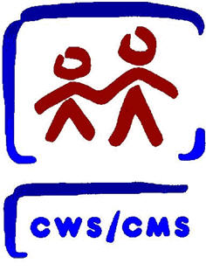

Table of Contents

Background 3
Importing into the CWS/CMS 3

Background

Counties now have functionality that will allow the importation of .pdf, .xls, .doc, .jpeg/.jpg, .docx, .xlsx and .txt files into the CWS/CMS application. The maximum size of any single file is 5 megabytes (MB). The exception for the maximum size of any single file is Placement Home. Placement Home files can be up to 10MB. There is also a maximum storage limit of 305MB for .jpg/.jpeg and .pdf files and unlimited storage for .doc, .xls, .docx, .xlsx and .txt files per Case, Case Plan, Client, Referral, Hearing, Placement and Resource Management Placement Home.

Importing into the CWS/CMS
When you are ready to import a file into the CWS/CMS application, use the following steps.

(A) Click on the Create New Document – Case button to open the Generate New Documents dialog box. (B) Click on the Import button. Rule 10812 added an Import File button in the Create New section on the Hearing ID page. Both methods follow the same steps shown below.

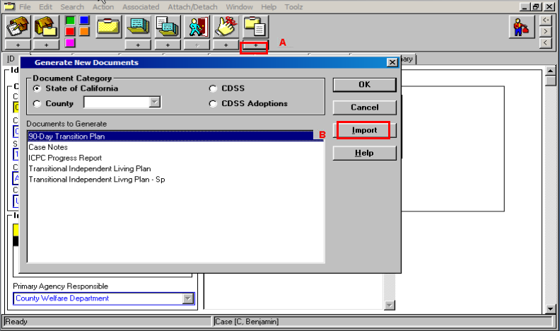

Select the file from the location where it is saved.

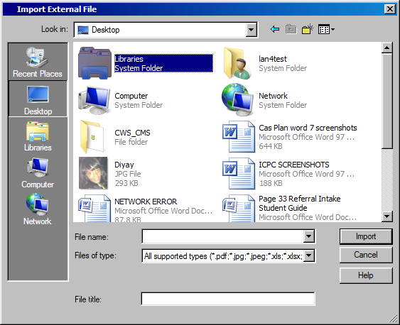

- Browse for and select the file that you wish to import
- Enter a title in the mandatory File title field
- Click Import

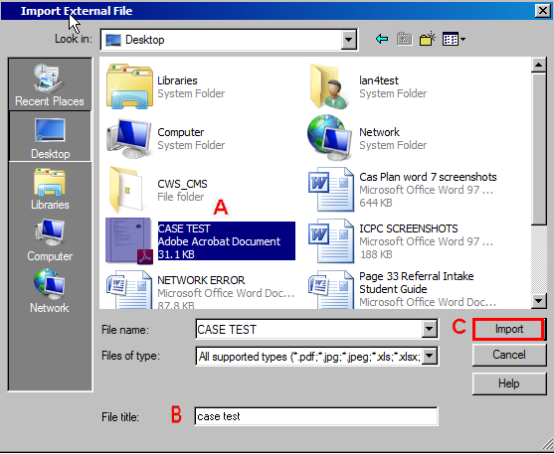

Once the image is imported, it will be opened in your default image viewer. Other file types will open in the default application.

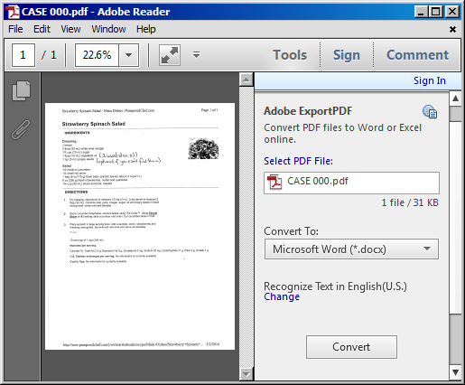

You can now retrieve the file the same way as you would other case documents by clicking on Open Existing Document – Case.

