Maine Department of Education, Assessment Office Hours
April 2, 2021

OVERVIEW OF THE SESSION
This document can be found here: https://tinyurl.com/nwearostering
The more technical version of this can be found here: https://tinyurl.com/nweaadhocsql

Introductions and Thank You’s

During today’s office hours we are going to show you how to import students into NWEA which is a critical first step in rostering. We’ll explore other ways to help you prepare your proctor sessions, as well as your staff data files which can be uploaded into NWEA. You can choose to listen or to follow along - this will be recorded and there will be a print guide shared.
We are pasting a Google Doc into the chat that you should find helpful and which includes some technical elements such as sample SQL queries for Infinite Campus and for Powerschool as well as sample templates and ad hoc queries designed to help you organize data in a way that best matches how data is ingested into NWEA.

By the end of the session you could have all your students that are required for assessment uploaded and ready for specific classes, instructors and proctors to be added as well. Knowing that who proctors your NWEA administration may not be clear to you yet, and that creating the spreadsheets or lists of classes and staff users may take a few more hours, we have scheduled a follow up technical session next Thursday April 8th at noon. Also, it is worth mentioning again that support is available to your district at 855-430-1777.

STUDENT DOWNLOAD FROM NEO

The Maine Department of Education (MDOE) has created a roster of students in grades 3-8 and 3rd year high school who are required to take the NWEA. This also includes 2nd year high school students for whom the NWEA is optional. Each day a roster is created from information within the State Synergy information system. So, as usually it is critically important that we as schools have frequent updates to Synergy during the assessment window. Remember it takes two to tango and so we need to try and resolve student enrollments as soon as we can so a receiving school can be aware that new student can be added. On the plus side, as we will see later, individual students CAN be added manually.

The roster is available in multiple formats on NEO. It is also able to be pulled school by school

Log in to NEO at https://neo.maine.gov/
(if you do not have an account they must be requested by your superintendent)
Click “Student Data” from the Dashboard or horizontal menu
Click “Click Here to Enter Student Reports”
Click View Report to the right of “NWEA Mathematics & Reading – Grades 3-8, 2nd & 3rd year HS”

From here you are able to determine which format you would like to download. You also can filter by school.

For the first part of this demonstration we will choose Excel. The Excel formatted download (which will open in Numbers or Google Sheets as well) will generate information in almost exactly the way NWEA roster files should be formatted.
Click the Floppy Disk Save option and choose Excel
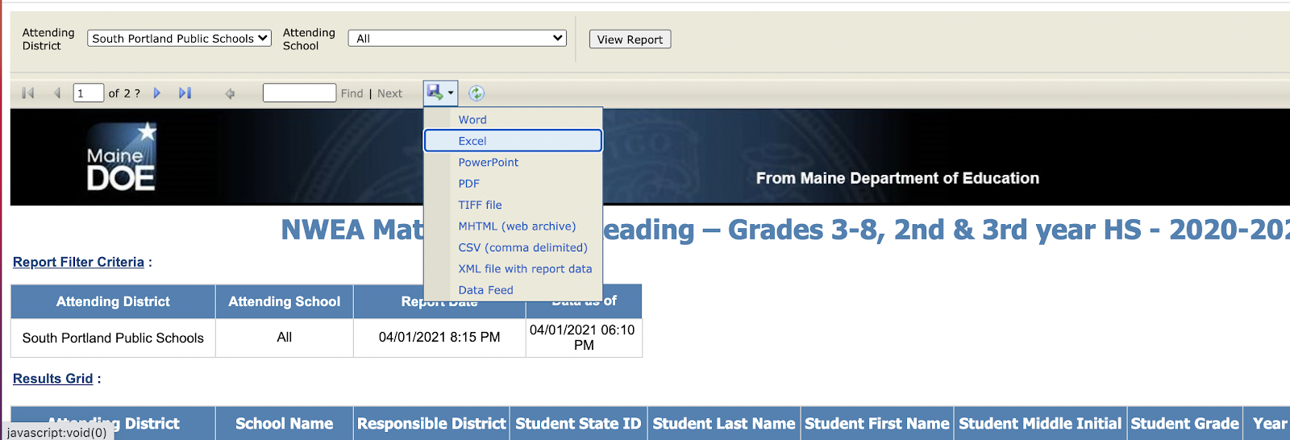

Delete rows 1-12 being sure to retain the blue headers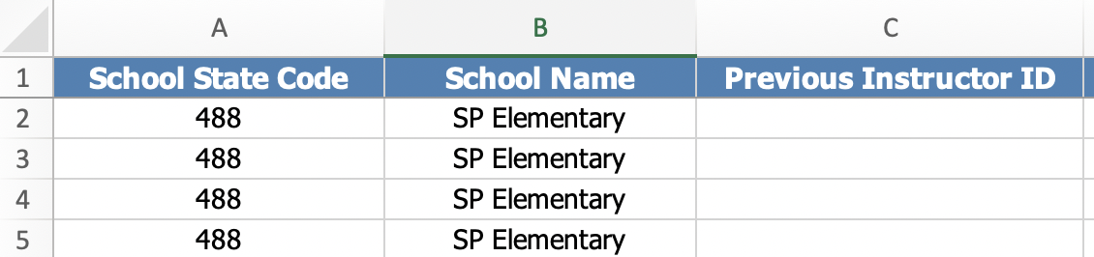

Click File - Save As and select Comma Separated Values csv
(be sure to select CSV comma separated values instead of csv-utf)
It’s common to get a data loss error, simply click the X
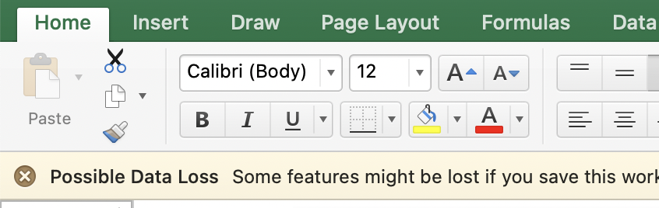

This CSV created from the NEO Excel download is what is needed to import your students into NWEA. For a more complete explanation of what each field means you can access the NWEA Roster File Template here.

You may have noticed other possible download types that can be pulled from NEO. The CSV version has value in rostering and planning.

The CSV version from NEO allows you to see more of the data that is behind the scenes. This can help you better plan your testing of students in the 3rd year of high school. It also tells you when a new student started in your district. As it is the raw data, it is NOT formatted for easy upload into NWEA. Consider it more as informational and a planning aid for high school assessment administration.
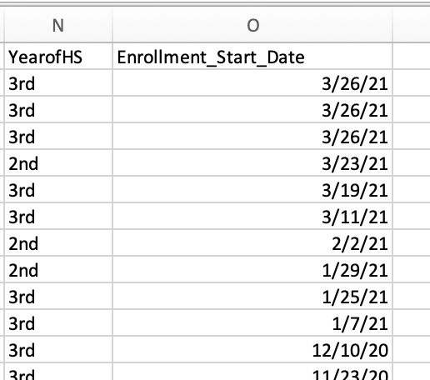

Now we will log into NWEA to demonstrate how to important student records. We will use “demo” student information as this is recorded and we want to respect student data privacy.

STUDENT-ONLY IMPORT TO NWEA

Downloading the Excel export from the NEO “NWEA Mathematics & Reading – Grades 3-8, 2nd & 3rd year HS” report will provide an excel file in the NWEA Roster File Template format. This will have all student information, but will be missing the required instructor information. You may either edit this file to add the missing teachers and classes, or import this file as a CSV using the student-only Import option to add the students into the MAP system. Please keep in mind, you will still need to import a full roster that includes the teacher and class information if performing a student-only import.

Please follow the steps below to perform a student-only import:
- Log into the MARC website at: https://teach.mapnwea.org
- Click Import Profiles/Rostering along the left
- Select Standard as the Roster Type, Spring 20-21 as the term, and Add/Update Students Only as shown in the image below
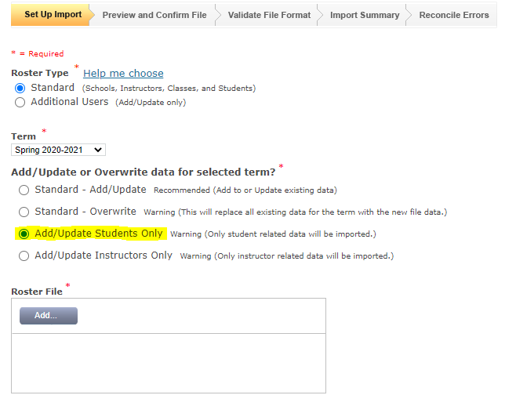

- Select the NEO export file. Please ensure you have followed the steps above to re-save the Excel file as a .CSV Comma Delimited file (Do not use the UTF-8 Option)
- Click Next to view a preview of the file
- Click Confirm to have the file checked for errors
- If errors are encountered, please view guidance available in the MAP Help Center to resolve.
  - If there are errors in the preview phase, please ensure your file is properly saved in .CSV comma delimited format and visit the above link for additional steps if needed
  - If there are file format errors, this indicates inconsistency within the file, such as two different students with the same ID. The website will identify the discrepancy for you and you can use the link above along with excel filtering to identify the inconsistencies and correct the file. You must then make the changes to the file, and begin the import process again.
  - If there are reconcilable errors, these can easily be corrected through the website. This means there is a mismatch between what is in the file and what currently exists in the system. These can range between incorrect school names to student information on the file not matching what is in the system. You will have the opportunity to correct the errors within the website.
    - Please reference the detailed error section below for screenshots and examples of Student Errors you may encounter.
- After any potential errors are resolved, you will need to click Post Valid Records to complete the import. This will populate the MAP system with the required students who need to test.
- Next, you will need to perform a standard roster import to add the missing class information. Please reference the Next Steps section below to pull this data from your SIS such as PowerSchool or InfiniteCampus.

Error Messages You May Encounter during Roster Import

School Name mismatches

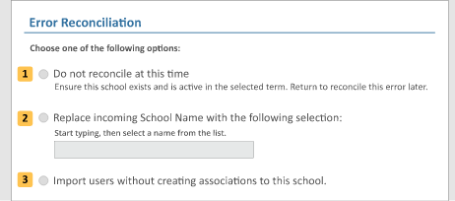
- For school name mismatches, you will want to select option 2 and then enter the name of your school as it is in the MAP system.
- You can confirm this by going to Modify Preferences along the left and clicking Modify District. The school names shown can be entered into the file or into the field inOption 2 to correct the error.

Student name/gender discrepancies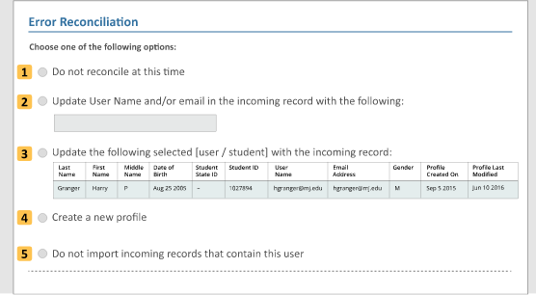
- If the student information in the file is different than what is already in the system, you will have student reconcilable errors with the options shown above. The data in the file itself is always considered the most recent.
- If the data in the file (which would be shown above Option 1 on your screen) is correct, you can select option 3 - Update the following record with the incoming record. You can compare the student information shown in option 3.
- If the info in option 3 is correct, you will want to update the info in your file to match what is shown and import again.
- Situations where this might happen could be due to a student’s preferred name not matching their legal name or gender coming out of NEO. As the Student State ID is the identifier for students, we recommend you roster with whatever name and gender that you want to appear on reports and on the screen for a student’s test. The Student State ID will tie the results back to the student’s record for DOE reporting.
How to export errors
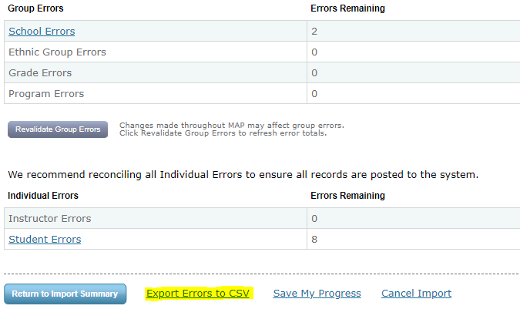
- If errors are encountered, you always have the option to Export Errors to CSV to more easily identify them. This can be useful if there were student reconcilable errors, but the data in the file is incorrect compared to what is in the system. Exporting these to CSV will help you know what edits to make in the roster file before re-importing.

Additional Help:
If you are having difficulty importing the roster or resolving errors that appear, NWEA has a Maine-specific help desk number available for troubleshooting and support at: 855-430-1777.

NEXT STEPS

SQL and Ad Hoc report samples can be found here.
When considering Proctoring approaches the instructor as proctor approach is easiest.

Demonstrate adding a single student
Demonstrate additional staff upload
Demonstrate adding a single staff member
Demonstrate adding a role to a single staff member

Remember there technical assistance Next Thursday, April 8th at 12pm as well as ongoing on demand help via the Maine specific helpline at 855-430-1777

For Sample SQL and Ad Hoc Reports please visit this Google Doc. As a community we will always be improving and building upon these, so please check version dates.

