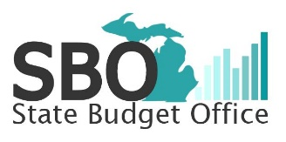
American Rescue Plan Proposal
School Aid
Great Start Readiness Program – Serve All Eligible Children
June 2021

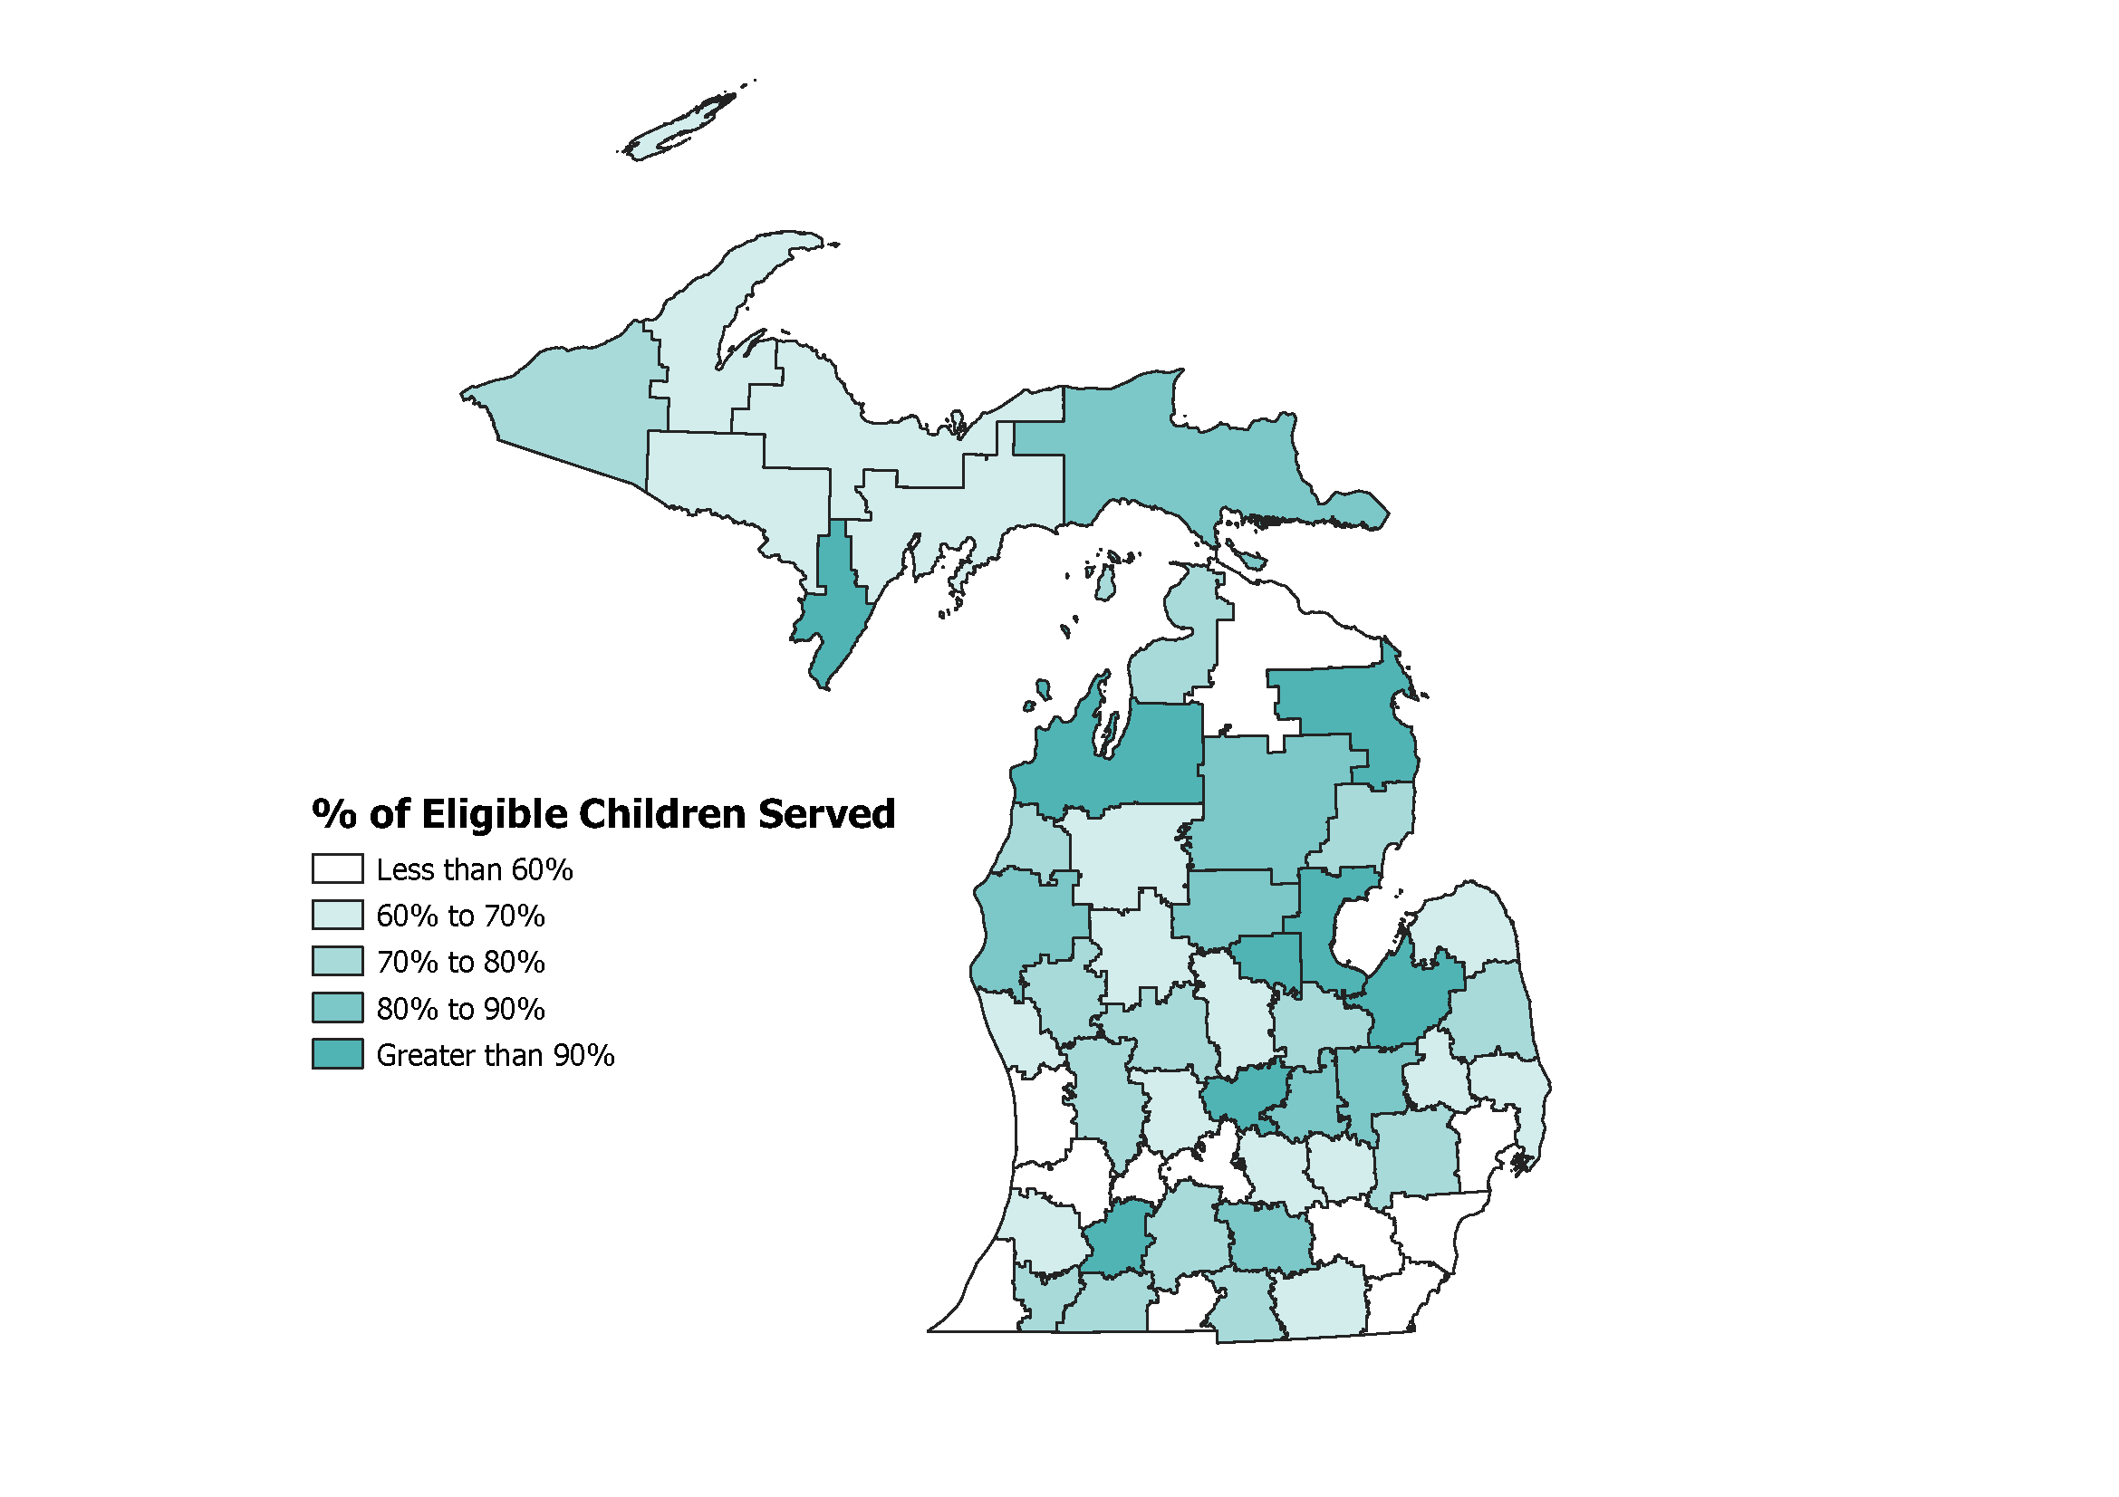
Current Law
Summary of Current Program
The Great Start Readiness Program (GSRP) provides preschool programming for Michigan’s at-risk 4-year-olds. In current law, $237.6 million is appropriated to provide full-day or part-day services to children coming from families at or below 250% of the federal poverty level ($66,250 for a family of four). Braided with the federal Head Start program, preschool programming is available to 43,100 of the state’s estimated 65,400 eligible children. This means that a third of the state’s most at-risk children, over 22,000, do not take part in state-funded preschool programming.

Existing allocations to 11 intermediate school districts (ISDs) allow fewer than 60% of their eligible children to be served and existing allocations to 41 ISDs allow fewer than 80% of their eligible children to be served.

Summary of Proposed Expansion
With additional federal funding available through the American Rescue Plan, the Governor proposes expanding preschool opportunities to all income-eligible 4-year-olds. This proposal invests $405 million ($255 million federal dollars and $150 million state School Aid Fund (SAF) dollars) over the next 3 years to fully implement the expansion, at an estimated ongoing annual cost of $152 million (SAF). Funding will be distributed through ISDs using the existing distribution formula. When fully implemented, 100% of the state’s eligible 4-year-olds will be have access to a program and an estimated 17,400 additional children will utilize the program, at a cost per full-day child of $8,692.

In addition, the Governor proposes investing $50 million federal dollars to expand preschool options in underserved areas, improve the quality of curriculum and instruction, support preschool teachers, and better connect parents and children with available programs.

Outcome Goals and Policy Focus
Research on preschool programs shows that children with high-quality preschool experiences demonstrate significant positive developmental differences compared to children from the same backgrounds without high-quality preschool experiences. These proposed investments will expand access to programs, expand the geographic availability of programs, improve the quality of programs, and make parents more aware of the importance of preschool and the available opportunities.
An investment in GSRP will prepare the state’s most at-risk children for success as they advance through the education system. The state will see the following long-term outcomes:
- Increased literacy performance by 3rd grade.
- Narrowed achievement gaps between high-income and low-income students.
- Increased high school graduation rates, creating a generation of Michiganders better equipped for skilled trades, college, and the jobs of tomorrow.

In the short-term, implementation will be measured through elimination of program waiting lists, an increase in the percent of eligible children attending preschool, and an increase in the number of programs being taught by highly qualified staff using current, research-based curriculum.

Sustainability of Funding
Federal funding is only available for the first three years of the expansion. To ensure ongoing sustainability of the proposal, federal funding is gradually replaced with state School Aid Fund dollars. By year 4 of the expansion, the goal is to be fully implemented and fully funded with ongoing state dollars. Annual growth in School Aid Fund revenues will more than offset increased costs, meaning that state dollars will still be available for other K-12 improvements.

